|  |  |
| --- | --- |
| PROJECT REPORT  Bank Management System | Abstract  The Bank management System mainly for customers use. |

**Contents**

LINK TO GOOGLE DRIVE 2

TECHNOLOGYUSED 2

TEAM MEMBERS 2

INTRODUCTION OF BANKING MANAGEMENT SYSTEM 3

Login J Frame 4

4

Create Account J Frame 4

Privacy Policy J Frame 6

Module J Frame 7

# LINK TO GOOGLE DRIVE

<https://drive.google.com/drive/folders/13BjLThjFGPC6xLvVUUpo0aURHm3qpW6g?usp=sharing>

# TECHNOLOGYUSED

* JAVA Language
* JAVA Swing

# TEAM MEMBERS

1. Saad Nisar Butt (cs211246)
2. Muhammad Moiz Alam (cs211205)
3. Adina M. Shoaib (cs211247)
4. Divya Rajwani (cs211252)

# INTRODUCTION TO BANK MANAGEMENT SYSTEM

This bank management system is for the convenience of a random customer. Its name is “The National Bank Of DSU”. A desktop application is made the bank management system so user can make his/her account, can do transactions, can apply for interest free loans. This desktop application is made with decent and simple graphical user interface and with the intention of good user experience. Using java language and swing for graphical user interface.

JFrames in Project

This bank management system has various functionalities for customer’s convenience. Each functionality is in different J Frames. Following are those J Frames.

* Log In Frame
* Create Account Frame
* Privacy policy frame
* Deposit Amount(initial) Frame
* Module Frame

1. View Account Details Tab
2. Deposit Amount Tab
3. Withdraw Amount Tab
4. Transaction Details Tab
5. Loan Tab

## Login J Frame

The login frame contains text fields to input account number of the user/customer and the password. Both these credentials should be entered valid or else an alert box will pop up and show user that invalid credentials are entered. If input goes well user will click on login button and account will open. Below here is .the visual of log in frame

## 

On the right side of log in button, there is create account button if a customer does not have an account so he/she can create account and then log in, By Clicking on Create Account Button, next J Frame will open so the user can create there account in bank.

## Create Account J Frame

In this frame user can create account very easily but there are some restrictions here. All fields are mandatory to fill. If any field remained empty, it will show a ‘Required’ below the text field. Each field has restrictions for input. Name cannot have and numbers or letters just alphabets (either lowercase or uppercase). Date of birth can have alphabets for month’s name or number and slash (“/ “& “-“) to separate date, month and year. CNIC field must contain 13 digits (numbers). It cannot have alphabets or special characters. Same for phone number field but instead of 13 digits, it should have 11 digits (numbers), nothing else. For email field there is a domain of “@email.com” is mandatory with user’s email address or else email will not be accepted. User has to choose if he/she wants to have a current account or saving account. Password field must contain at least 7 and at most 15 characters. Then it must have at least one lowercase alphabet, one uppercase alphabet, one number and a special character. Password and confirm password must match or else it’ll show a pop up. When user clicks on submit button account number will automatically be generated in account number’s field. Account number will comprise of users entered NIC’s last 5 numbers and 3 random numbers, total of 8. There is a back button also, by clicking on this user will brought back to login page.

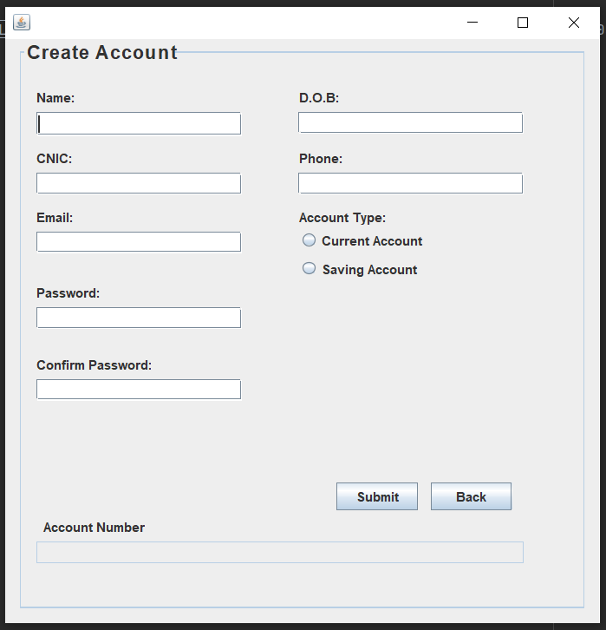

On submitting, this form a pop will generate which show you your account number and also the input field which is disabled, in it account number will be generated for further processing.

## Privacy Policy J Frame

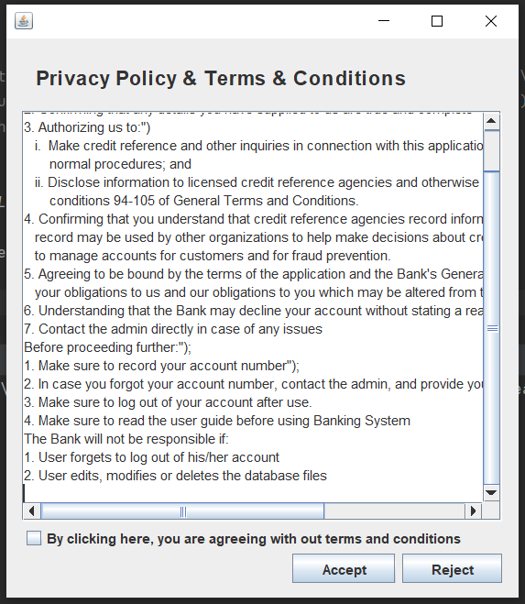

Privacy policy frame contains policies of bank and terms and conditions for a customer having bank account, user first has to check the checkbox and accept then his/her account will be generated. Else on clicking on rejected account will not be created and user will brought back to log in page.

## Module J Frame

This j frame is for customer’s module which will open up after logging in with valid credentials. This j frame is comprised of five different tabs with different functionalities which our user can perform. At the top user can see his/her name written and just on other side there is a log out button so user can log out and go to log in frame again.

* View Account Details

In the tab of view account details, user can view his/her details which were entered at the time of account creation. Account number, name, CNIC, phone number, email address, date of birth, account type and balance. Balance will be updated as per transactions done by user.

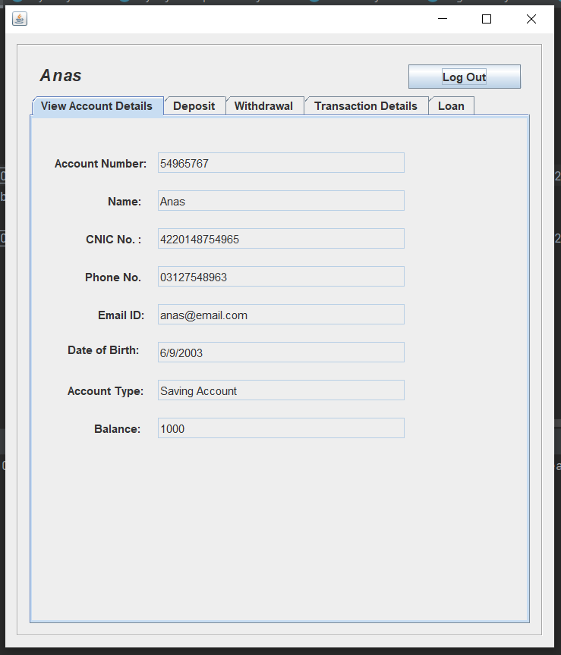

* Deposit

Deposit tab is actually same as the tab user would face at the time of account creation because one user has to deposit some amount in his/her account. Here Deposit tab has same functionality and user can deposit amount whenever he/she wants. Amount deposited will be updated and then user can see those updates in balance on next time log in. In the field user can’t enter amount lesser than 0 or else it will be treated as invalid input.

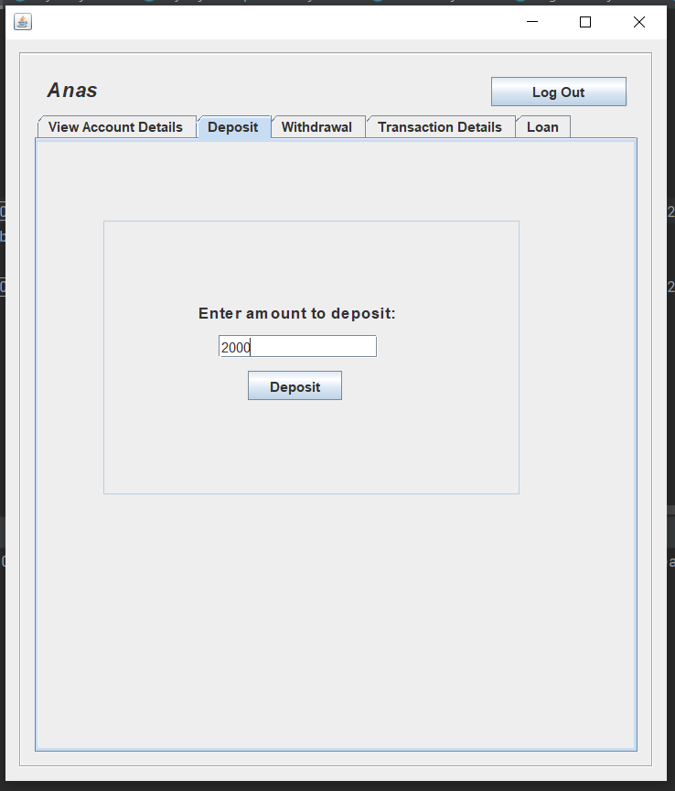

* Withdraw

In withdraw tab user can withdraw some amount from his/her account and the balance will be updated after each transaction. Here also, user can’t enter amount less than 0 as it is invalid. Another restriction is that user has to enter amount which is less that the amount currently present in the bank or else he/she cannot withdraw.

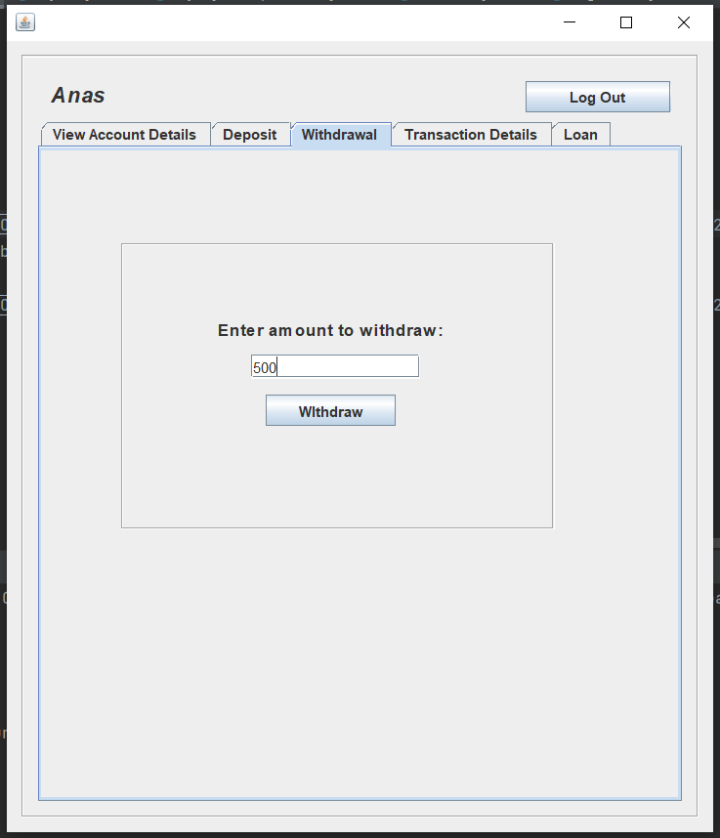

* Transaction Details

In tab of transaction details, user can view his/her transaction history like lastly amount deposited or withdrawn. It will show in a table. At first the initially deposited amount and at last, lastly done transaction.

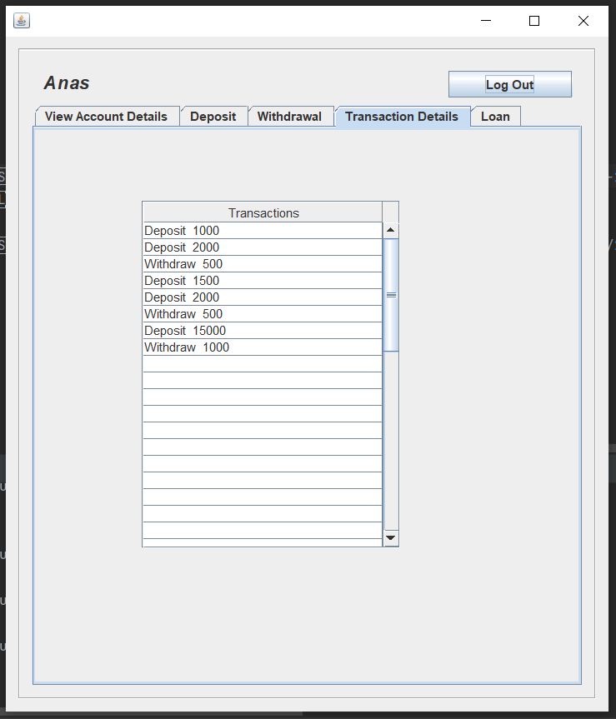

* Loan

Last but not the least, loan tab. Loan tab is for customer to apply for loan.make sure that here loans are interest free. Bank provides three types of loans, loan for property, loan for education and loan against fixed deposit. If property loan is selected some requirements will change accordingly but some remains same. User should select source of income and enter into installments field, number of months and loan percent required. Whereas loan percent limit will be different for every loan. Here is the description for loans.

**Property Loan:** If applying for loan for property, customer has to enter market value of property. The loan percent is up to 60% for loan against property.

**Education Loan:** If applying for loan for education, customer has to enter annual fees amount of educational institute for which applying for loan. The loan percent is up to 80% for loan against property.

**Fixed Deposit Loan:** If applying for loan for fixed deposit, customer has to enter amount which is currently present in his/her account because it is loan against fixed deposit. The loan percent is up to 70% for loan against property.

When all requirements for calculation for loan will be fulfilled, loan amount will be calculated and appear in field of loan amount and installment amount to pay back the loan to bank will appear in field of installment amount. User can see details and if want so request for loan by clicking on request button. A pop will generate to tell user about the process of loan request and how. he/she can acknowledge if he/she has got loan from bank or not .

